Cluster Task 9

1. Add Cluster in the diagram

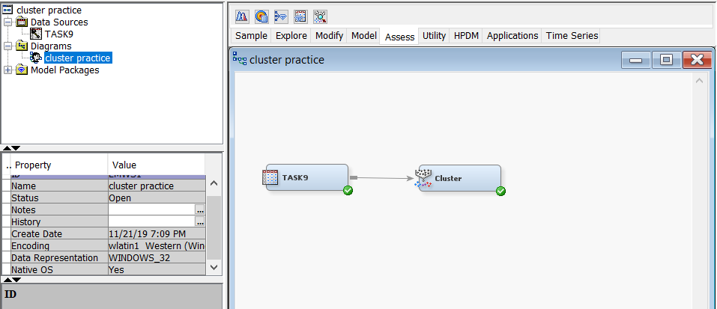

1. Then run and display the result.

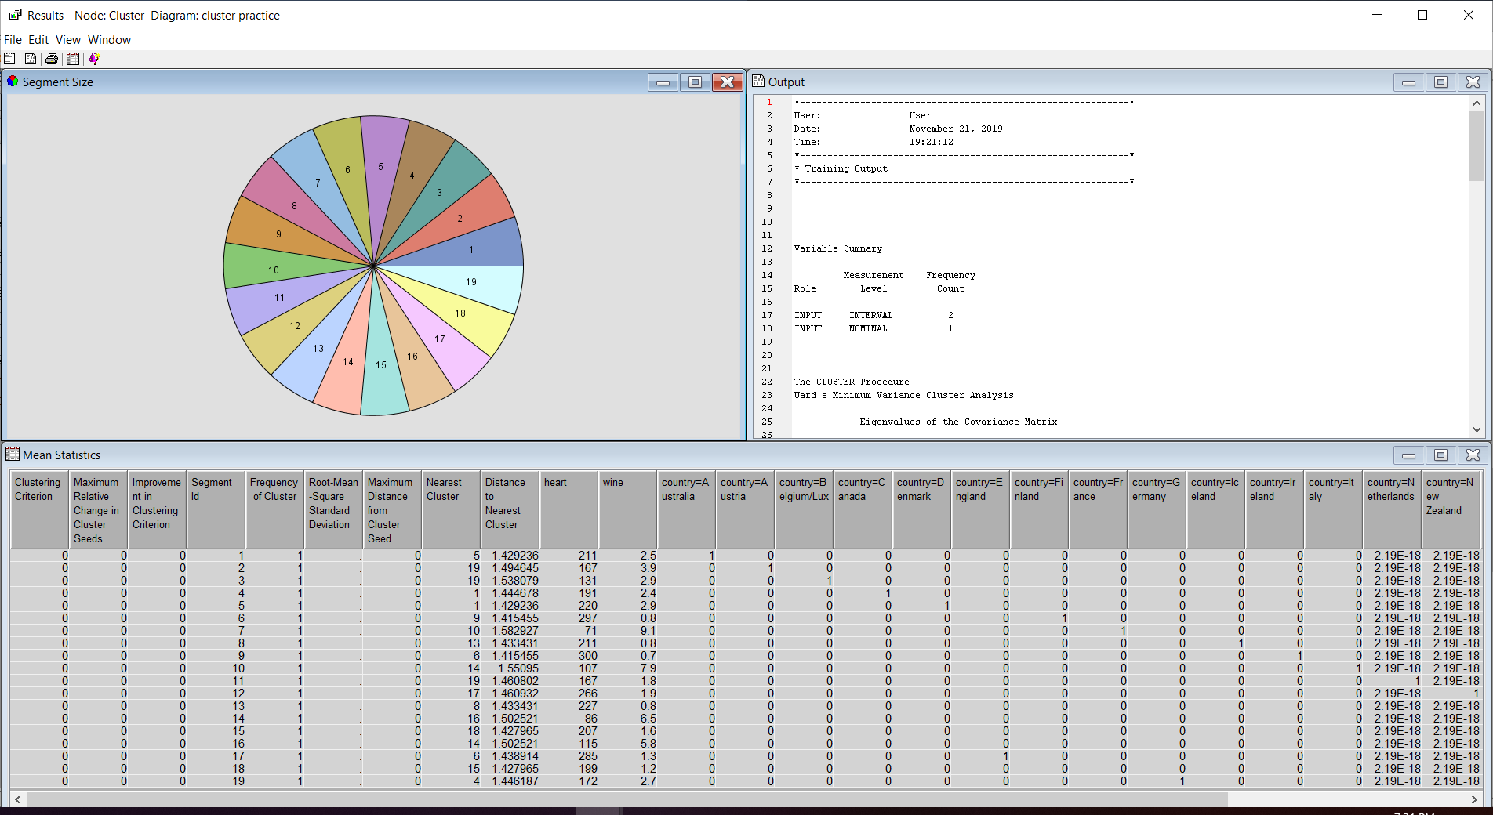

1. Change Specification Method and Maximum number of cluster as image below.

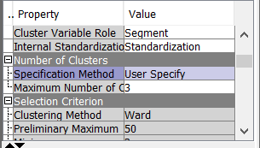

1. Then run and display the result.

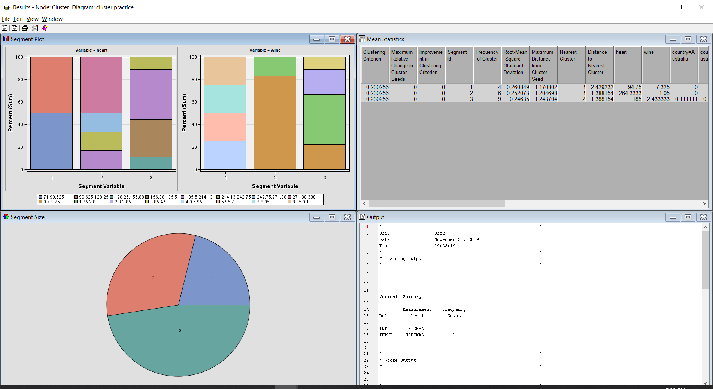

1. Added the **Segment Profile** to diagram to examine segment or cluster data and identify factor that differentiate data segment from population.

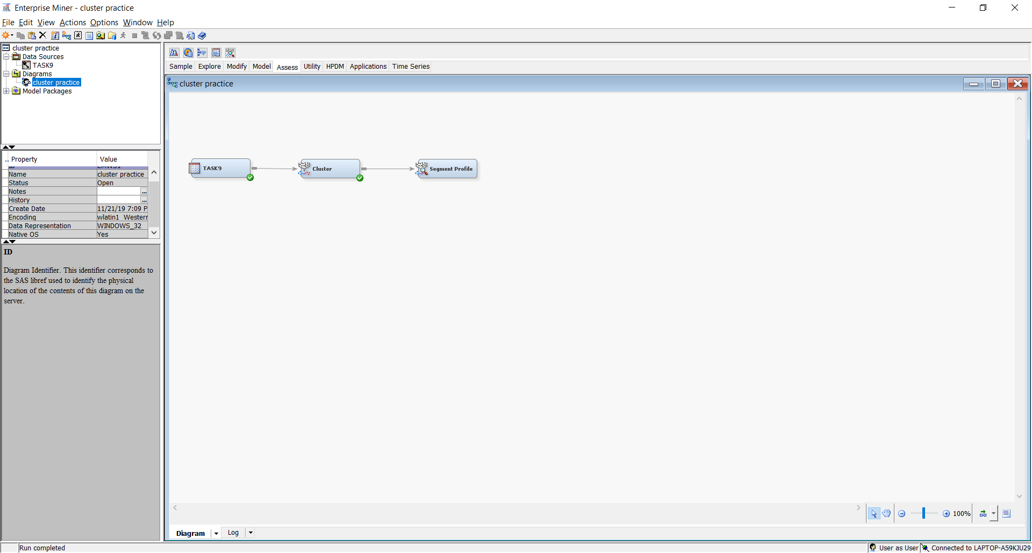

1. Then run and display the result.

